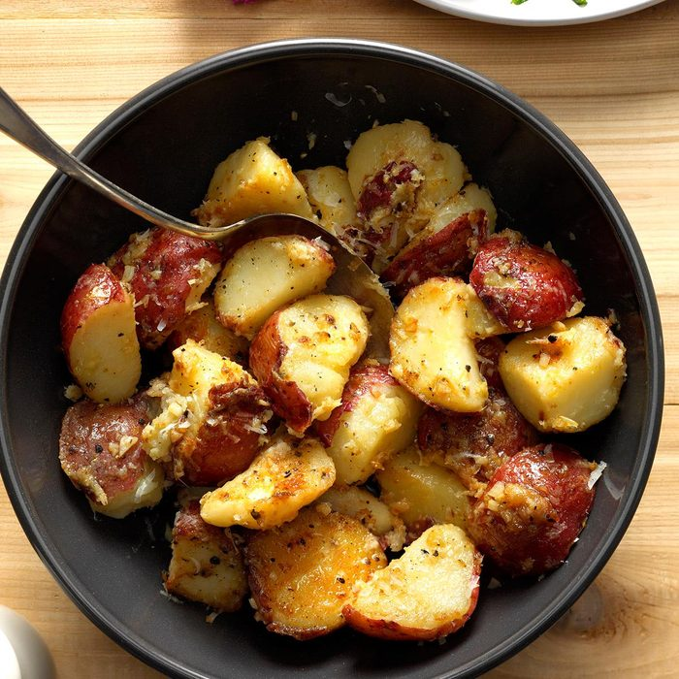
Lemon and Garlic New potatoes

Ingredients
- 1 pound small red potatoes
- 2 tablespoons olive oil
- 2 garlic cloves, minced
- 1/4 cup shredded Parmesan cheese
- 2 tablespoons lemon juice
- 1/4 teaspoon salt
- 1/4 teaspoon pepper

Directions

Cut scrubbed potatoes into wedges; place in a large saucepan. Add water to cover; bring to a boil. Cook, covered, until tender, 10-15 minutes; drain. In the same pan, heat oil over medium-high heat. Add potatoes; cook until browned, 4-6 minutes. Add garlic; cook 1 minute longer. Remove from heat. Stir in remaining ingredients.

