Maple Dijon Mustard dressing

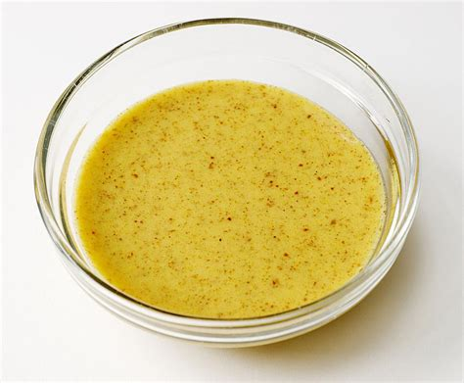
Ingredients
- 2 tablespoons white wine vinegar
- 1 tablespoon Dijon mustard
- 1 teaspoon maple syrup
- ¼ teaspoon kosher salt
- 6 tablespoons olive oil

Instructions
- In a medium bowl, whisk together the white wine vinegar, Dijon mustard, maple syrup, and kosher salt.
- Whisk in the olive oil 1 tablespoon at a time until a creamy emulsion forms. Store refrigerated and bring to room temperature before serving (keeps at least 2 weeks).

