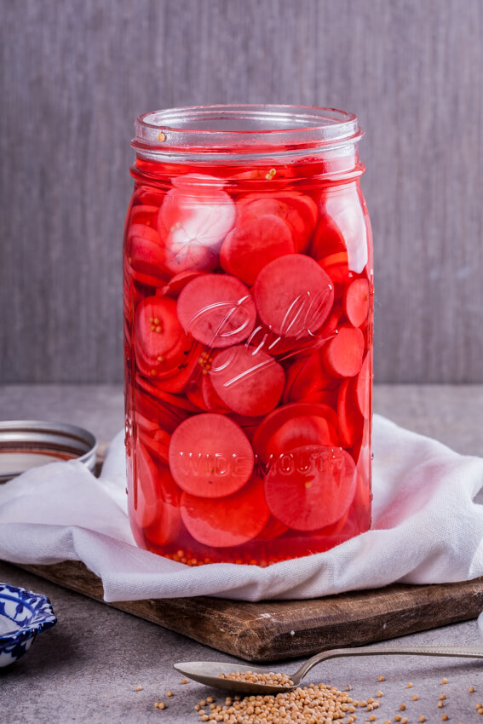
Simple pickled Radishes

INGREDIENTS
- Fresh radishes.
- White vinegar/apple cider vinegar.
- Spices: Mustard seeds, black peppercorns/cracked black pepper, bay leaf, red pepper flakes/chilli flakes, salt.
- Sugar.

HOW TO PICKLE RADISHES
- Prepare the radishes: Wash radishes well and remove leaves and stems. Slice the radishes thinly with a sharp knife or a mandolin slicer and place in a sterilized jar.
- Make the pickling liquid: Heat vinegar, spices, sugar and salt in a small saucepan until the sugar dissolves then pour the brine over the sliced radishes.
- Seal and store: Seal the jar and allow to cool. Allow the radishes to pickle for at least 2-3 days but up to 4 months in the fridge.

