# **Red Wine Vinaigrette**

## **Ingredients**

* 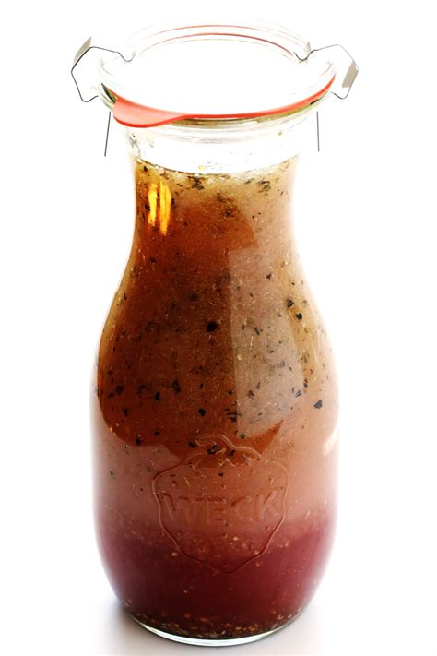½ cup extra-virgin olive oil
* 3 tablespoons red wine vinegar
* 1 tablespoon maple syrup
* 1 tablespoon Dijon mustard
* 1 tablespoon minced shallot (Optional)
* ½ teaspoon Italian seasoning
* salt and freshly ground black pepper to taste

## **Directions**

1. Combine olive oil, red wine vinegar, maple syrup, Dijon mustard, shallot, Italian seasoning, salt, and pepper in a jar with a lid. Shake to combine until mixture is emulsified, about 20 seconds. Adjust salt and pepper, if needed.