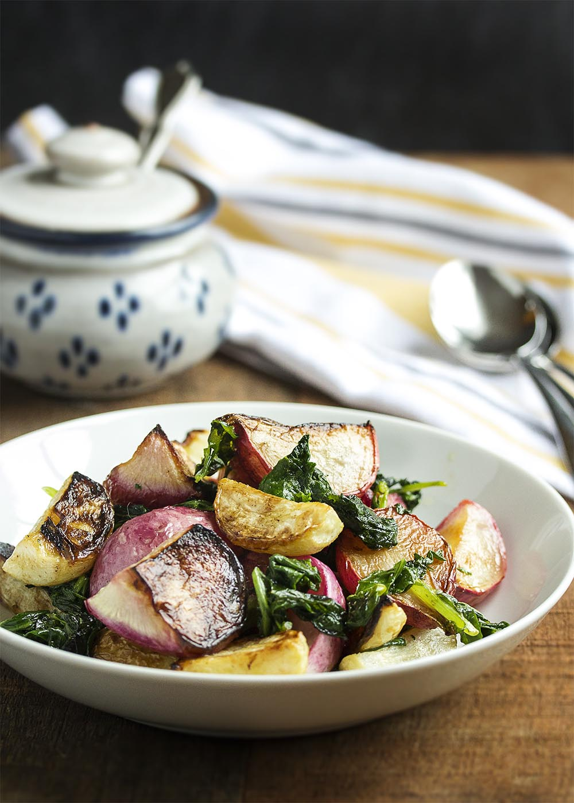
Roasted Hakurei Turnips and Radishes

Ingredients
- 1 bunch radishes
- 1 bunch Hakurei turnips, or other mild salad turnips
- 3 tbsp olive oil
- 1 tsp kosher salt

Instructions
- Move the rack in the oven to the lower middle position. Place the roasting pan in the oven.
- Preheat oven to 425F.
- Slice the greens off the turnips and radishes.
- Scrub the turnips and radishes well to remove all the dirt and grit from the vegetables, and rinse the greens repeatedly until they are grit free. If you left a little bit of the stem on the radishes and turnips, make sure you clean around it well since dirt collects there. I find scraping around the stem as I wash cleans it up nicely.
- Cut the turnips and radishes into wedges. Halve the small ones, and quarter or sixth the larger ones.
- In a large bowl, toss the vegetables with 2 tbsp of olive oil and 1/2 tsp of salt. Pour the vegetables into the roasting pan, arranging them so most have a flat side down in the pan.
- Roast for 15 minutes, stirring and turning the vegetables at 7 minutes.
Dry the washed greens to remove most of the water. Roughly chop the greens into bite-sized pieces, then toss them in the large bowl with the rest of the olive oil and the salt.
- Pull the roasting pan out of the oven, turn and stir the vegetables again and then make a space for the greens. Spread out the greens in the space and return the pan to the oven.
- Roast for 5 minutes more

