Zucchini Boats

Ingredients

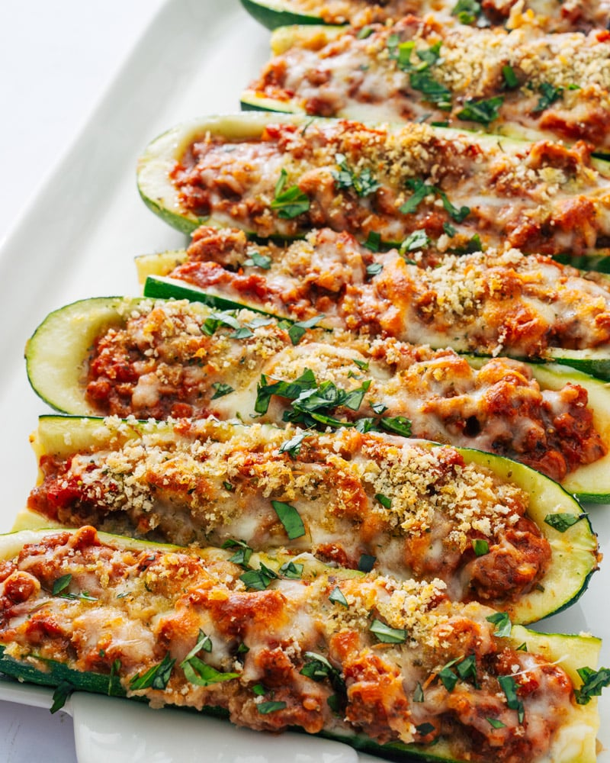
Zucchini!!!!
- Sausage: plant-based sausage, crumbles, or standard Italian sausage
- Garlic
- Fire roasted tomatoes
- Dried oregano, fennel seeks, salt and pepper
- Parmesan cheese
- Mozzarella cheese (whole milk)
- Italian panko (or breadcrumbs)
- Fresh basil or parsley

Instructions
- Preheat the oven to 425°F.
- Cut off the stem ends of the zucchini. Cut them each in half lengthwise and scoop out the insides with a spoon: you’ll want a thin edge around the outside of the boat. (Discard the pulp, or use it in smoothies or for another purpose.) Place the boats on a baking sheet and rub each with a bit of olive oil. Then sprinkle all 8 boats with a heaping ¼ teaspoon salt, ½ teaspoon oregano and fresh ground black pepper, divided between the boats.
- Place the sausage in a medium skillet and cook according to the package instructions, 2 to 3 minutes for plant-based and 6 to 7 for regular sausage (for regular sausage, drain any excess fat after cooking). Add the garlic to the pan with the sausage and cook 30 seconds, then add the tomatoes, fennel seed, ½ teaspoon dried oregano, ½ teaspoon kosher salt, and ¼ cup Parmesan cheese. Heat for 1 minute until warmed through.
- Scoop the filling into the zucchini boats. Top with the mozzarella cheese and the remaining 2 tablespoons Parmesan cheese. Then sprinkle with the panko.
- Bake for 20 minutes until the cheese is melted and golden brown. Let stand for 2 minutes before serving. Leftovers store up to 3 days refrigerated.

