## Ingredients

For 4 servings

1 1/2 lb chicken breast, or boneless chicken thighs, cut into 1 1/2 inch pieces

3/4 cup greek yogurt

3 tablespoons olive oil, plus extra for grill

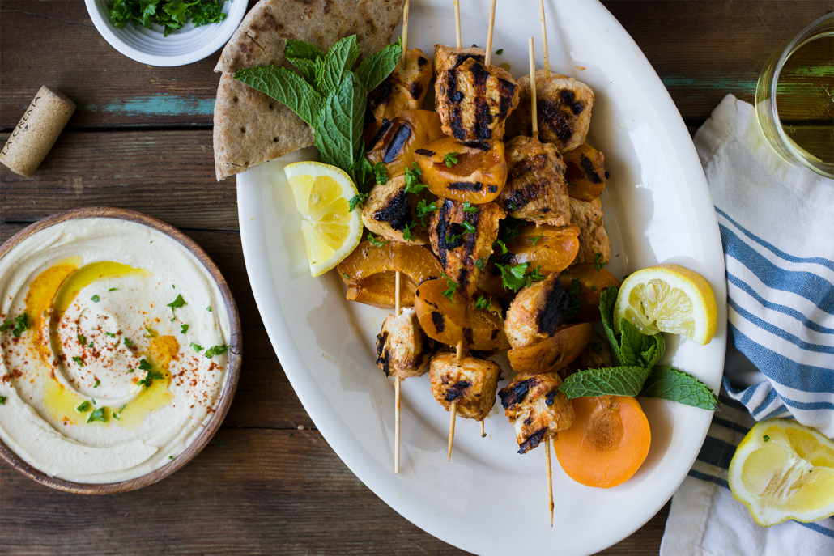4 cloves garlic, minced

1 1/2 teaspoon smoked paprika

1 teaspoon cayenne pepper

2 tablespoons fresh lemon juice

1 1/2 teaspoon cumin

1 teaspoon salt

1/2 teaspoon pepper

3 tablespoons tomato paste

8 bamboo skewers

4 apricots, pit removed and quartered

## **Preparation**

1. Whisk all of the ingredients together in medium bowl until combined, then pour into a medium sealable plastic bag. Add the cubed chicken and massage a bit to evenly to ensue the chicken is evenly coated with the yogurt marinade. Place the plastic bag in the refrigerator for 2-3 hours to marinate.
2. Begin to soak bamboo skewers at least 30 minutes before you are ready to grill the chicken.
3. Remove the chicken from the plastic bag and skewer one cube of chicken followed by one quarter of an apricot onto the skewer. Repeat this order one more time, then add a third piece of chicken and set aside. Repeat this process until eight skewers have been assembled.
4. Season the chicken with a bit of salt then place the skewers onto either a lightly greased outdoor grill, or into a lightly greased grill pan that has been set to medium high heat. Cook the skewers for eight to ten minutes, rotating halfway through. Check chicken and cook for an additional minute if necessary. Remove skewers from grill once the chicken is cooked through and their juices run clear.